CLOTH FEMININE PAD PATTERN
Materials List
1 yard lightweight flannel fabric (will make approx. 10-12 pads)
1/2 yard low loft cotton quilt batting (ex: "Warm & Natural")
Size 14 (Denim) needle

FEMININE PAD - CUTTING INSTRUCTIONS
Step 1:
Download “pad pattern” from sewinpeace@blogspot.com
and transfer to lightweight cardboard. (File folders or cereal boxes work great!)
Pattern measures approximately 7 1/2” from side to side and 8 1/2” in length.
Measurements may vary depending on the printer.

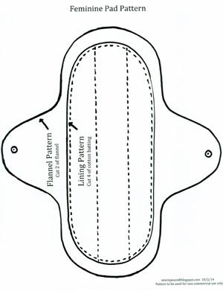

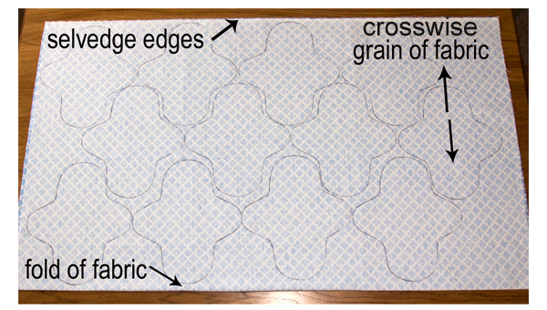
Step 2:
Iron fabric. Fold fabric in half, printed sides together matching selvedge edges. Trace pad pattern onto fabric using a pen, being careful to follow the crosswise grain of the fabric.
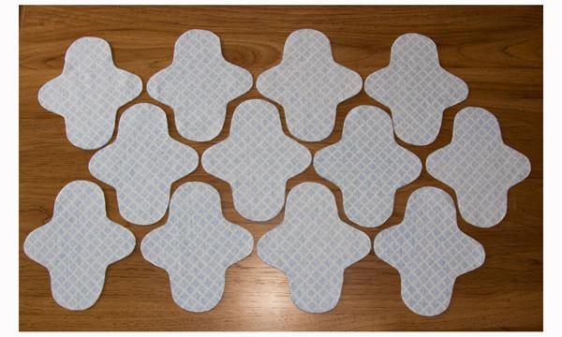
Step 3:
Using a sharp scissors, carefully cut fabric. Set fabric aside keeping layers together.
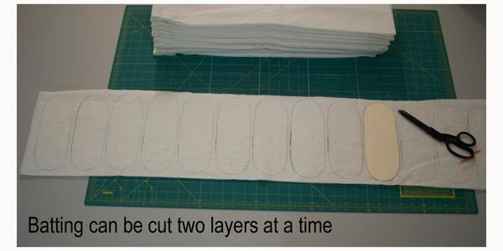
Step 4:
Fold cotton batting in half forming two layers. Trace
lining pattern onto batting, and cut.
1
FEMININE PAD - SEWING INSTRUCTIONS

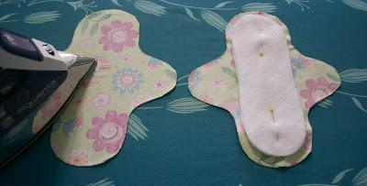
Step 5:
Iron flannel and lay fabric printed side down.
Center two layers of cotton batting on each
piece of flannel, and pin in place.

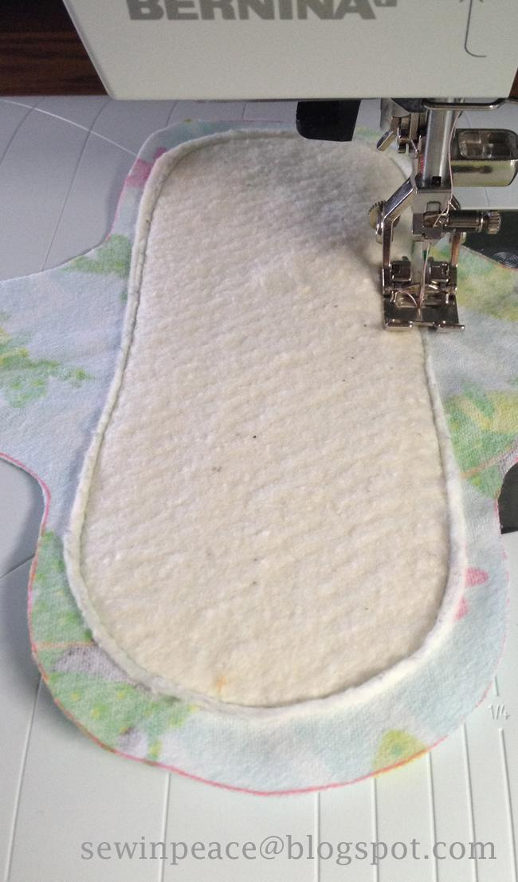
Step 6:
Straight stitch around edge of cotton batting using a size 14
(Denim) needle. Backstitch to secure seam. Repeat stitching on
second flannel piece.

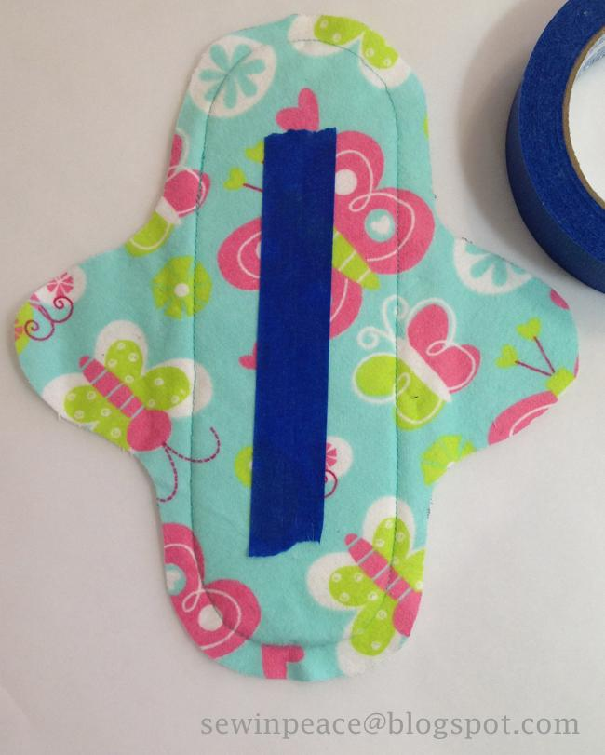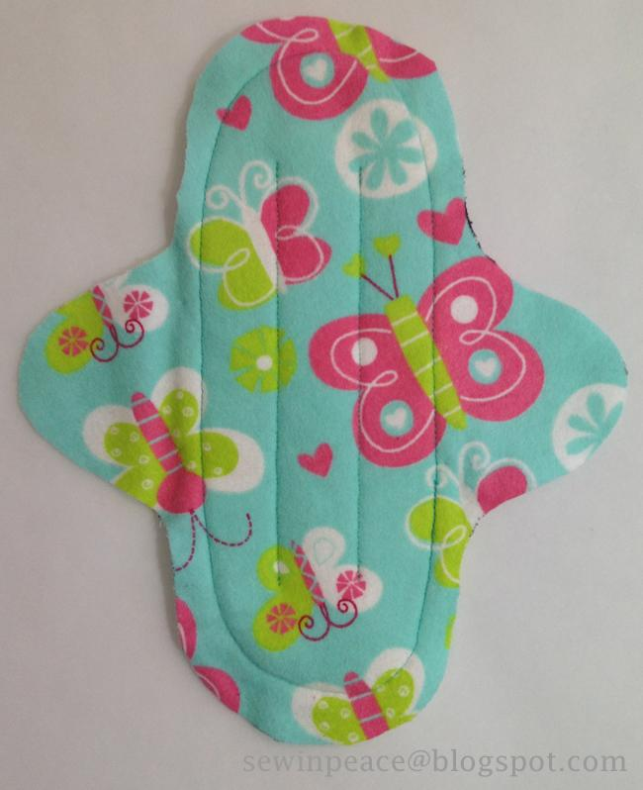
Step 7:
On each piece of flannel stitch two lines down the center. Backstitch to secure stitching. You may find it helpful to use a walking foot and to decrease the tension setting on your machine. Painter’s tape is used in the photo to show a stitching guideline.

2

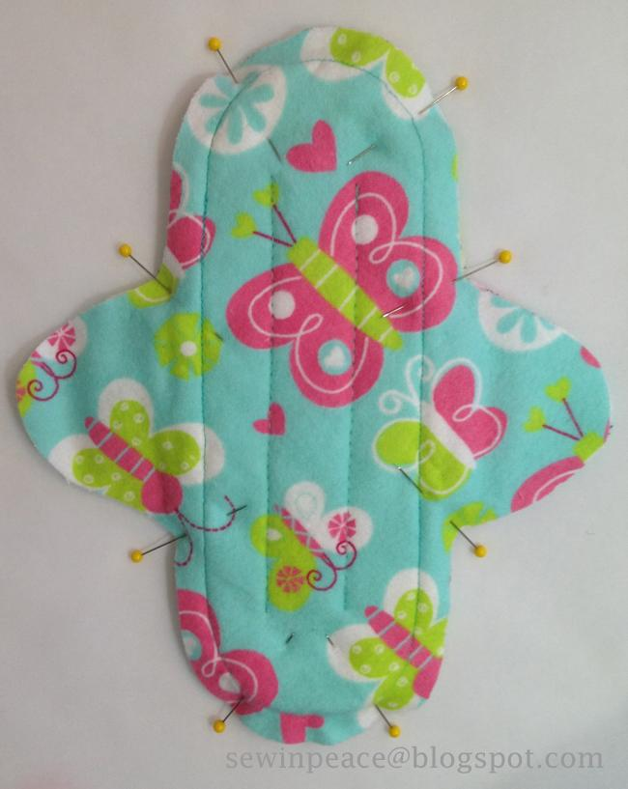
Step 8:
If needed, trim so edges are uniform. Pin together flannel layers printed sides out, carefully matching edges.

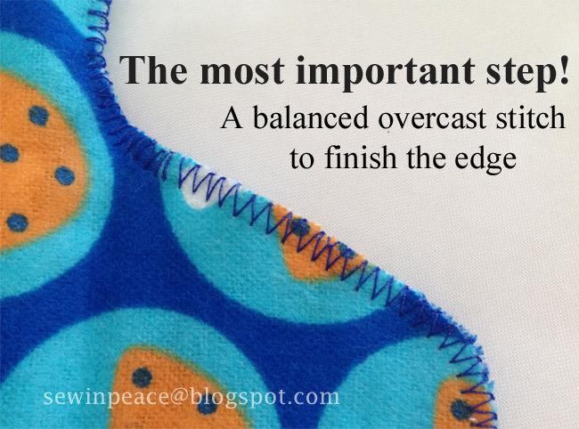
Step 9:
Use an overcast or zigzag stitch to finish edge of fabric.
With the “zig” the needle will move to the left piercing into the fabric. With the “zag” the needle will move to the right dropping off the fabric creating an overcast stitch.
Suggested stitch length 1.5 x width 5.0
Backstitch to secure seam.

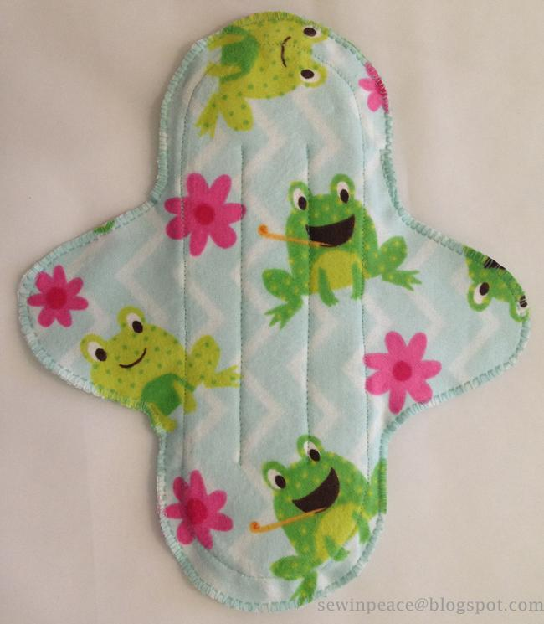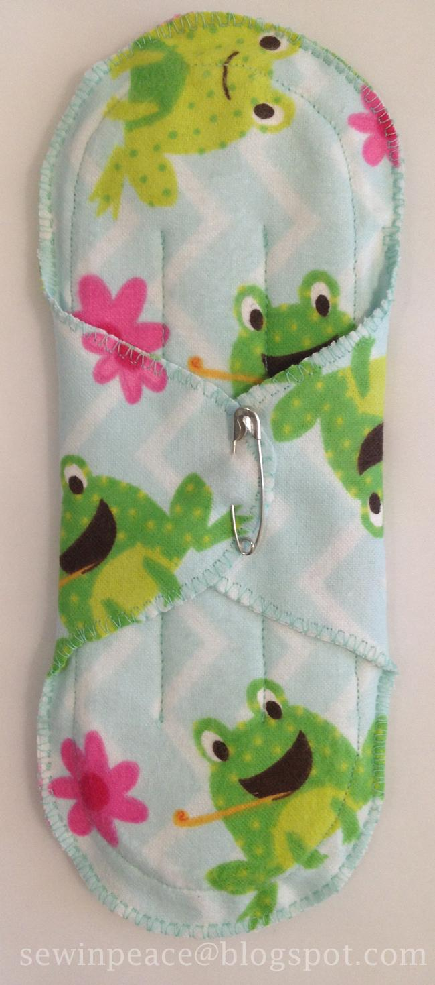
Optional: Use velcro or a safety pin to close. You are finished! How pretty!

3
Additional tips and techniques can be found at sewinpeace@blogspot.com
Pattern to be used for non-commercial use only. Updated 8/3/16

